JDBC Assignment screenshot :

Create Table in JDBC

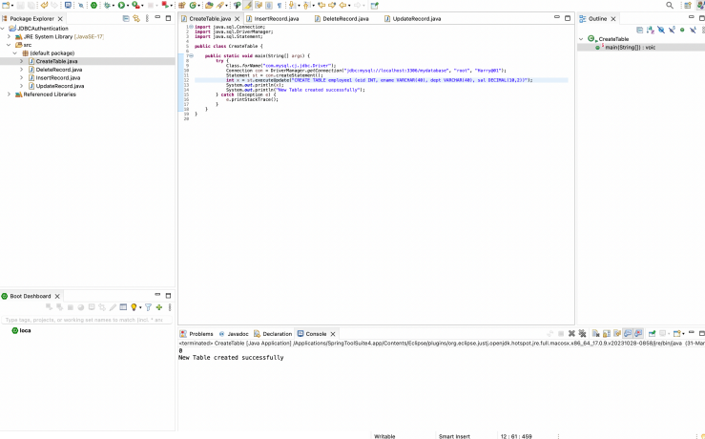

Insert Data in JDBC :

